This document provides the necessary instructions for completing the Week 1 lab exercises. This exercises are mainly slight modifications of Week 1 class examples already provided.

**Exercise 1: Demonstrating Inheritance**

Create a new Eclipse project named **Week1LabExercises**. Create a package **exercise1**. Copy to this package the classes **CreditCard.java** and **PredatoryCreditCard.java**. These classes can be found in **Lesson1Examples** project, respectively under *primer* and *design* packages.

Run the exercise. Modify the *main* method by making another call to the *charge* method and printing the summary of the card using *printSummary* method. Run the exercise again and interpret the results.

**Exercise 2: Demonstrating abstract classes**

Consider the inheritance hierarchy from Lesson1Examples:

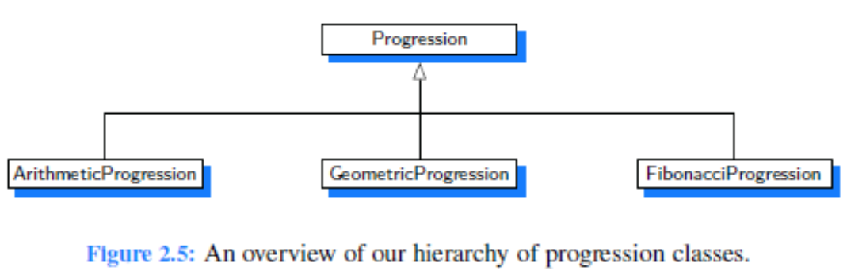

**Progression** class is a concrete class. In this hierarchy, replace the Progression class with the abstract class, **AbstractProgression**. To do this, the subclasses ArithmeticProgression, GeomtericProgression, and FibonacciProgression, should now extend **AbstractProgression.**

Test the new inheritance hierarchy.

**Exercise 3: Demonstrating the interfaces.**

Write a main class to test the **BoxedItem** class from Lesson1Examples. Class **BoxedItem** implements two interfaces, **Sellable** and **Transportable**. Test the methods of both interfaces implemented in **BoxedItem** class, in the *main* method of the main class you will create.

**Exercise 4: Demonstrating Generics in Java**

Consider the **Pair.java** class in Lesson1Examples. Test this class with different pairs of objects by adding the corresponding code in the *main* method. For example, create **Pair** objects for <String, String>, <Integer, Integer>, etc.